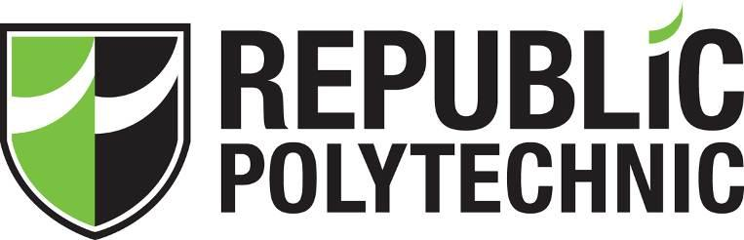

SOI-2017-1710-xxx

ELECTRONIC DUTY ROSTER SYSTEM FOR PART-TIME ABC

Date of Submission: 08-August-2021

Submitted By:

|  |  |
| --- | --- |
| 19060228 | Student A |
| 19044179 | Student B |
| 19057616 | Student C |
| 19021605 | Student D |

# ACKNOWLEDGEMENTS

We wish to express our sincere gratitude to the following persons for their time, effort and cooperation who are involved in the project. MR A our supervisor for dedicating his time to help us in our Final Year Project and guide us when we are in doubt. He is always patient and sincere in teaching us, cracking jokes to make the atmosphere light and enjoyable. It also helps us to relieve stress at the same time being serious in our work. He teaches us patiently and teach us step by step in what we are supposed to do each week so that we are on track and do a good job in presenting to the COMPANY A organization. He is very experienced in being a good supervisor and I would recommend him to any other team be in high gpa or low gpa. Thank You for being there for us in this 13 weeks and we are grateful and lucky to have you as our supervisor.

**TABLE OF CONTENTS**

ACKNOWLEDGEMENTS 2

ABSTRACT 4

1 Introduction 5

2 Project Specification and Plan 7

2.1 Project Overview 7

2.2 Functional Requirements 7

2.3 Project Plan 9

3 Business Analysis 10

3.1 Business Issues 10

3.2 Business Solutions 11

4 System Design and Implementation 12

4.1 Database design 12

4.2 Use case design & Use case specification 14

5 Unit & Integration Testing 14

6 User and Technical Documentations 14

6.1 User Documentation/Guide & Prototype 14

7 Conclusions 15

References 18

# ABSTRACT

Our team name, ‘Aurora’ was given an industry for final year project(Final Year Project ) with a duration of 5 months. We are to develop an online booking system for Part-Time (PT) ABC to book their duties. The system can track the number of duties and hours performed by each PT APO. Based on what we were taught back in year 2, we decided to choose Web application module and apply our knowledge & skills using Visual Studio software. By the guidance from our supervisor, Mr Mr A, we were able to gather the accurate requirements based on the industry project for COMPANY A PTE LTD.

The project implemented an automatic online manual system for all super admin, user and other two admins roles for different cluster. In order to output database reports, the system can generate reports for each role instead of keying in records manually into excel and thereafter printout hard copy which may be time consuming. Nevertheless, our industry consultant, Felicia, she can give us information and user-requirements regarding the project functionalities and clarify our doubts in a timely manner. Hence, making this system user friendly will serve as an avenue for PT APO to take ownership in booking their duties.

# Introduction

Initially, the company uses manually hard copy paper records. We are to upgrade into a systematic automated booking system. When a book their shift dates, cluster and attendance, those records are saved into the allocated database. The user can book their event dates in advanced. Thus, it helps to reduce duplication and minimize data error. The system can also automatic demote and promote the user according to its tier status which super admin and cluster admin can keep track of.

The most important thing will be staff do not need to manually calculate the working hours of each part timer since it is complicated and tedious to calculate 1 by 1 and the data might not be accurate, with this project we can calculate the working hours accurately using the web application by doing hard coding and export the data into an excel for tracking purpose.

This problem is important to solve because it is frustrating for the admins to always manually keeping track of attendance records, if the administrator misplaced the hard copy paper, they are unable to retrieve the information. As for the user, booking events updated in the announcement page are visible to all as admin do not need to make a call. However, it can resolve the problem by using the electronic booking system to update information in the database. It enables the super admin to take control for all admins and user accounts and to keep track of how long the part-timer has worked.

The system shall have the ability to generate man power reports such as book events, attendance, hours clocked by the part timers. As for administrator (Super Admin), who is able to see the backend database to generate data for different types of shifts and clusters and manage all the part timers and create new admins when necessary. In Addition, super admin will need to do promotion and demotion for part timers if they did not meet the requirements of working 48 hours in 3 months.

With an automated online booking system, it is easier for staff to track records. Part timers do not need to report or contact their boss to let them know they are working on the day. Part timers can access the website using any devices with a username and password to log in. With a backend database, all information will be stored permanently and securely. Administrator from each cluster will be able to see how many staff are present or absent on that day. Some functions such as if the officer fails to clock 48 hours for that month, administrator (super admin) will demote the part timer from tier 1 to tier 2.

The system must have a back-end server for them to use the website. There are a few resistances to the proposed new system. The resistance includes concerns on re-learning how to use the new system functionalities. Therefore, a user guide document must be provided.

The main results are part-timers can book their shifts online, they are also able to book events and clusters shifts, view announcement board, and cancel their shifts if they are unable to make it as well as updating their own profile.

Super admin will manage the whole database and add new admin as well as new part timer. Super admin are able to promote and demote staff, view all the staff from different clusters, active and inactive, create and view announcement board, update profile, add tier/cluster/sub cluster, add new shift, rank, role, location, driving class, skill, generate report for the whole clusters. Admins from WCP and Prison can view their own cluster part timers, view certain information from each part timer, view and change their own profile, mark attendance, generate monthly report from each cluster and include remarks from each part timer to state why they are not able to make it.

# 

# Project Specification and Plan

## Project Overview

The COMPANY A part timers have been marking attendance manually and they have decided to change this to a systematic marking attendance system. It is easier to track how many part timers can work on a specific day or transfer them to another tier if they do not meet the 48 hrs worked within 3 months. It will benefit administrators since it is able to save time and resources. It is very tedious to use hard copy paper and record attendance and if the records are lost, it is hard to recover since it is a paper format. The benefits will be that part timers are able to book their duties online with any smartphone devices. Moreover, administrators can track and update the attendance of the part-timers to generate reports to monitor manpower availability on that day as well as clocked the number of hours.

The major tasks will be User are required to clock at least 48hrs per month for a consecutive of 3mths. If the User fails to meet this requirement he will be barred to book the slots for tier 1 sites. Part timers can only access ad hoc events open for booking site that they are deployed to by Super Admin and they are able to update their Personal.

## Functional Requirements

To understand the system better, we decided to use Rapid Application Development, we did a prototype from gathering the requirements from COMPANY As and show a prototype using PowerPoint slides as it will give an idea of business logic and process flow from the system. Functional requirements are identified from different users called actors. Actors have different roles and as a team we came up with a use case diagram and a cycle called analysis design iteration to build the prototype. We finalize all our built codes using Visual Studio.

The major tasks will be User are required to clock at least 48hrs per month for a consecutive of 3mths. If the User fails to meet this requirement he will be barred to book the slots for tier 1 sites. Part timers can only access ad hoc events open for booking site that they are deployed to by Super Admin and they are able to update their Personal Particulars.

Admin can only acknowledge the booking made by the Part timers after the time of deployment. He/she shall be able to view the Personal Particulars of the officers assigned to his/her site. Administrator of each cluster are able to mark attendance and generate cluster report for WCP/Prison.

Super Admin has access to everything. From making amendment to the enrolment template and etc. The ability to broadcast emails on Adhoc Events to only a few selected group of the Part timers individually. Superadmin can also manage the whole database and transfer staff to another cluster if they are lacking manpower on that cluster. Super Admin can promote and demote staff if the part timer did not meet the requirements.

All part timers must be able to book their duties online with any electronic devices such as tablet, smart phones, desktop, laptop etc.

There are some assumptions when the system is on live, the performance will be slow when migrating from the old version 2015 to the newest version of visual studio 2017.

## Project Plan

We planned a detailed Gantt chart and state all the deliverables and activities for each member and divide the workload for each member. Our supervisor has stated clearly on what are our roles which we are to be involved for this project and guided us throughout this 13 weeks of weekly final year project meeting. He also checked on our progress & performance in our individual roles according and give us tasks based on our individual coding strengths. Jingjing is the Super admin who manages the overall databases/reports and has the authority to all other roles too. She has a highest power to promote /demote staff, transfer staff, view all profiles of each part timer for all clusters. Jess and Damaris are given the permission as admins to be in charge of each cluster name WCP & Prison. Each admin handles the attendance by viewing certain part timer information and able to search by part timer ID and input remarks while Angeline the user (part timer) is in charge of booking the cluster shifts, events and checking for new announcements, managing the sub clusters etc.



# Business Analysis

COMPANY A is a security business providing manpower management of security services for different clusters. They have a lot of full time staff as well as part time staff manage by security officers. They need to schedule manpower at different clusters and they have a manual booking system to consider online booking system to more effectively manage their manpower and manage the shortfall for manpower, allocation to tiers, shifts & cluster. This is very useful in predicting their schedule of manpower needed daily leads to implement a system called **COMPANY A INTELLIGENT MANAGEMENT BOOKING SYSTEM**. The system aims to alleviate the tediousness of manual spreadsheet input and better predict manpower resources and processes.

This system can manage 500-1000 part timers and manage different 2-3 clusters and the system may be expanded if the need arises. It has information of part timer information allows updating of skills set because different cluster require set of skills based on the tier approach. The system aims to fulfil all the different functionalities as specified in the use case diagram. The system can also customize & suit the needs of customers in different iterative approach. This benefits the company by tracking those data in an effective manner of automatic system.

## Business Issues

The current process is doing manual work by using paper records. The officers have to approach their team leader to give their work schedule. This may result in miscommunication & human error when the team leader repetitive asked for the schedule to ensure that there are sufficient manpower working on that day. The automated system comes in handy of recording attendance data, event data, calculate monthly work hours in the report on excel. It will definitely reduce workload since it is much easier for them to track the data and use it for future reference. It can also help them to have a look out on how many part timers are working on that day and transfer staff to another cluster if the specific department lack of manpower.

* What are the difficulties or business issues that we are trying to solve?

The first difficulty will be calculating the monthly working hours of each staff since we need to accurately know what shift timing are they working. They need to meet the 48 hours requirements within 3 months, if the part timers fail, they will be debarred from tier 1 so it is hard to track manually since it is done by human which will be more prone to human errors.

The second difficulty will be officers find it a hassle to approach their team leader to give their work schedule to their team leader, and with using the new automated system they are able to reduce the manual way of doing things which will improve on the work processors. It is very important that the staff can book their dates in advance via online. It increases the flexibility to book when they wish to work leads to no miscommunication.

The third difficulty will be generating those reports and import user data manually. Nevertheless, everything need to be done manually and does not benefit company and staff. There is a higher possibility for the staff to produce 100% accuracy of the user data with the help of automation system to improve on their work process.

## Business Solutions

IT helps to analyse all the data loaded automatically without having human to do it manually which are most likely to cause human error. In addition, it will take time for the company to gather other information required for the automated system, clarification of steps involve and to implement the changes to come out with a prototype design interface. After confirming the prototype design interface, proceeding to the next step of codes is necessary which will allow our team to understand the business logic and overall business process.

# System Design and Implementation

This section will briefly explain the usage of web application development to code our project and in order to view the website, the web server will run it.

## Database design



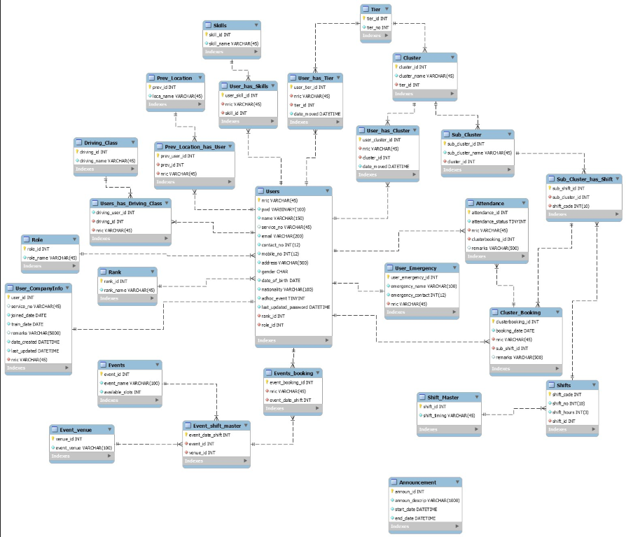

## Use case design & Use case specification



# Unit & Integration Testing



# User and Technical Documentations

## User Documentation/Guide & prototype



# Conclusions

During this project, we have developed a sense of teamwork skills, we set our dedicated roles and our own responsibilities for this 13 weeks goal to be reached. Periodically, we set our time every week, prioritise what needs to be accomplish of different tasks, under the direction of our leader & supervisor in ensuring that the team assesses its progress. We developed mutual respect and understanding towards each other. We applied IT Project Management (ITPM) constraints such as resource, time and scope. Even though we might have our differences and opinions, we worked together every week to solve them through good communication and ensure that the teammates are able to meet the targeted deadline. On top of it, we know our strengths and weaknesses by helping one another whenever we need help in certain areas and bounce ideas off. Everyone learns to share in victory when things go well or re-strategize when there is room for improvement on project.

During 13 weeks, we have developed a booking system for COMPANY A for part timers to book their schedule via an online booking system. We ensure that the system is flexible such that all devices such as desktop, phone tablets can access them and adjust the size based on the screen sizes.

We faced some problems such as contacting the industry person in charge to gather more requirements and clear our doubts. This causes us to wait patiently for their response as they are busy with work, sometimes they include harder industry requirements which we did not learn during our coding modules. In fact, it was a challenge for us to search online for additional source codes which is quite difficult. The namespace would be another issue so in order to solve them we need to ensure that the namespace for everyone will be the same. The hardest part will be debugging the errors since the errors contains ambiguous explanation which we are unable to debugged. Another tedious part will be compiling the codes since all of the codes need to be able to successfully run without any errors.

Checking for login for all roles would be an issue since everyone has different clusters and information in the database. The session name need to be the same to run the website. Accommodating our teammates schedule will be another issue since we need to match each other timing to arrange to do the project and constantly updating on WhatsApp chat group regarding our available day where all of us can meet up to do the project.

The main problem will be once we compile the codes and send to each other, some of us are unable to open the project due to certain errors. This makes us feel quite frustrated as we are not able to understand what exactly those ambiguous error occurs a few times. It was really time consuming because we help one another by dealing with the error at the same time doing our own parts of the project. It seems funny when the rest of the team mates are able to run the project successfully. We managed to resolve it by googling the problem to our solution on that error.

What we have achieved so far will be, the super admin is able to promote and demote part timers, create new part timers, view all part timers, add sub clusters shift, view, add, delete all admin, view all users, search users based on service no, filter records by active/inactive/all users, create view/delete/edit announcement, manage the whole database and update personal information and emergency contact. Super admin can also add new tier, cluster, sub cluster, add sub-cluster shift, add cluster shift master, add rank, role, location, driving class, skill.

Admins from WCP /Prison are able to view all part timers for each respective clusters, search id based on each user id, search for attendance record, admin can also view attendance record and mark attendance based on each shifts. Admin can view remarks from user when they are unable to report to work due to certain reasons. Admin can view certain information from each user and they can update their personal information and emergency contact.

Users (PART TIMER) can view announcement when they login into the system, they can book clusters and select a sub cluster based on different shift number. In addition, users can view events and check available slot left and select reporting venue and time. Users can view all booking, edit booking and cancel booking 3 days in advance. Users can also view cluster booking, edit and cancel booking. Users can update their personal information and update their emergency contact. They can also view the contact us page with the company address, email, contact number and their official hours. User can send enquiry via email when they have questions regarding about staff deployment etc.

Lastly, by making improvements to the existing system such as  scalable to add in more cluster , automation to promote/demote users, manpower allocation to be downloaded in excel ,view via phone and import the part timer details into the system.

# References

* Call a C# function in ASP.NET when clicking on a HTML link. (n.d.). Retrieved July 31, 2017, from https://stackoverflow.com/questions/4537490/call-a-c-sharp-function-in-asp-net-when-clicking-on-a-html-link
* Copy a single row from one datatable to other. (n.d.). Retrieved July 31, 2017, from https://stackoverflow.com/questions/10330173/copy-a-single-row-from-one-datatable-to-other
* (n.d.). Retrieved July 31, 2017, from https://www.w3schools.com/w3css/w3css_buttons.asp

# 